Chapter 5, Solution 15

(a) Let v₁ be the voltage at the node where the three resistors meet. Applying KCL at this node gives

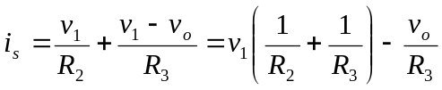 (1)
At the inverting terminal,

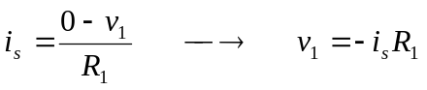 (2)
Combining (1) and (2) leads to
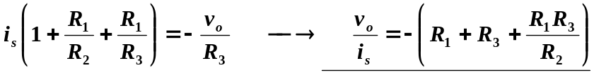

- For this case,

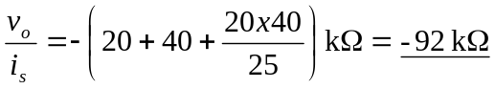

= –92 kΩ

